Question 1
What is the optimal value of alpha for ridge and lasso regression? What will be the changes in the model if
you choose double the value of alpha for both ridge and lasso? What will be the most important predictor
variables after the change is implemented?

Answer: There is no standard optimal value for alpha in lasso and ridge regression. The best practice for this
will be to obtain alpha value using Gridsearch cross validation by passing a parameter grid. This can either be
integers or logspace. For better accuracy, it is recommended to use logspace.
As shown in the syntax below, this will perform the regression based on the estimator(ridge or lasso based
on the algorithm used) and return the model.
folds = 5
model_cv = GridSearchCV(estimator = ridge/lasso,
param_grid = params,
scoring= 'neg_mean_absolute_error',
cv = folds,
return_train_score=True,
verbose = 1)
model_cv.best_params_ will then return the optimal value of alpha based on the data.
If Alpha is doubled under Ridge regression, bias of the model will increase and variance will be reduced and
as a result, multicollinearity is handled much more aggressively
If Alpha is doubled under Lasso regression, more coefficients are driven towards zero. This will cause the
model to be sparse and it will perform feature selection aggressively. In the end, only dominant predictors
will survive.
Even for lasso, bias will increase and variance will reduce
The most important predictor variables will be the variables that exhibit high predictive strength, low
multicollinearity, and stable coefficient estimates across samples.

Question 2
You have determined the optimal value of lambda for ridge and lasso regression during the assignment. Now,
which one will you choose to apply and why?
Answer: Based on the assignment, I will chose lasso as it performed the feature selection and in the final
output, lasso regression had the highest R2 score of 8.48…

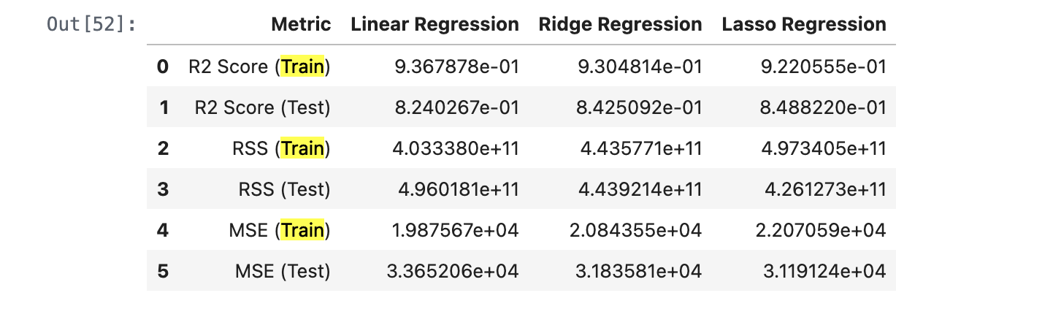

Question 4
How can you make sure that a model is robust and generalisable? What are the implications of the same for
the accuracy of the model and why?
Answer: A model can be made robust and generalisable by using cross-validation, regularisation, proper
data splitting, and feature selection. These techniques intentionally reduce training accuracy to control
variance and prevent overfitting. As a result, although training accuracy may decrease, test accuracy becomes
more reliable and representative of real-world performance

